Thank you, friends.

Since arriving to western Colorado in April we have been settling into what appears to be an extended time of ministry “state-side”. Our ministry with the Quechua people of the Cotahuasi Canyon has not slowed, and we are serving with them on the phone, texting, and video meetings many hours each week including morning devotions, admin, and biblical counseling.
The epidemic in Peru is one of the most serious in the world has surpassing most others in numbers of sickened people and deaths. Hospitals reached capacity months ago, oxygen is in short supply with prices entirely out of reach for most families. People are left outside the entrance of the main hospital of Arequipa because there is no room for them inside.

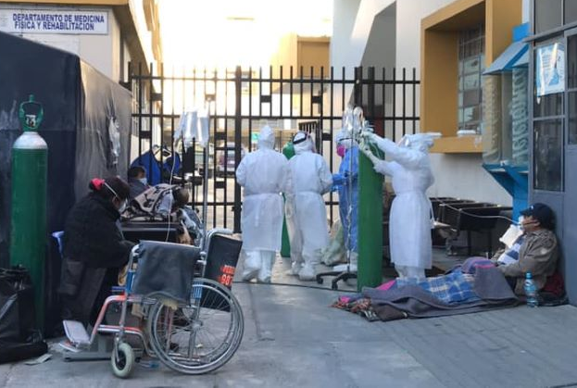

Increasing force of government restrictions on travel, no flights within, into, or out of Peru, daily curfews, no gatherings of people, and mandatory mask use have not been able to stop the spread. Since mid-March shut down has created an economic disaster. Still no buses to Cotahuasi.

In and around the Cotahuasi Canyon the cases have been very few up until the last few weeks. Now they are growing in number. Each of the Quechua team members have relatives who have died already, all who lived in the cities of Peru.

Brother Jaime Luque passed away last week of COVID, owner of the local general store.

So, while we remember our Quechua brothers in Christ who are suffering these days, we remember our faithful, loving Lord and savior and how He cares for them. And we are so encouraged and strengthened by your prayers and gifts toward the support of the radio ministry, church planting, mercy ministries of food and medical care, and theological training. We give thanks to the Lord for giving us such a faithful and encouraging prayer team who are continuing to serve Him with us. Together, our hope is to see more and more Quechua believers trusting Jesus and faithfully obeying Christ for His glory.

Special giving has helped the Quechua team in current efforts to give food and clothing to those in dire need during the economic shut-down. Having the resources available has really helped the ministry team in Cotahuasi as they purchase supplies they give to needy families. They remain steadfast in their hope and are working hard toward the goal to have the short-wave radio transmitter broadcasting the gospel to the southern Peruvian Andes mountain villages. Praise the Lord, the Christian radio programs and daily discipleship continues.

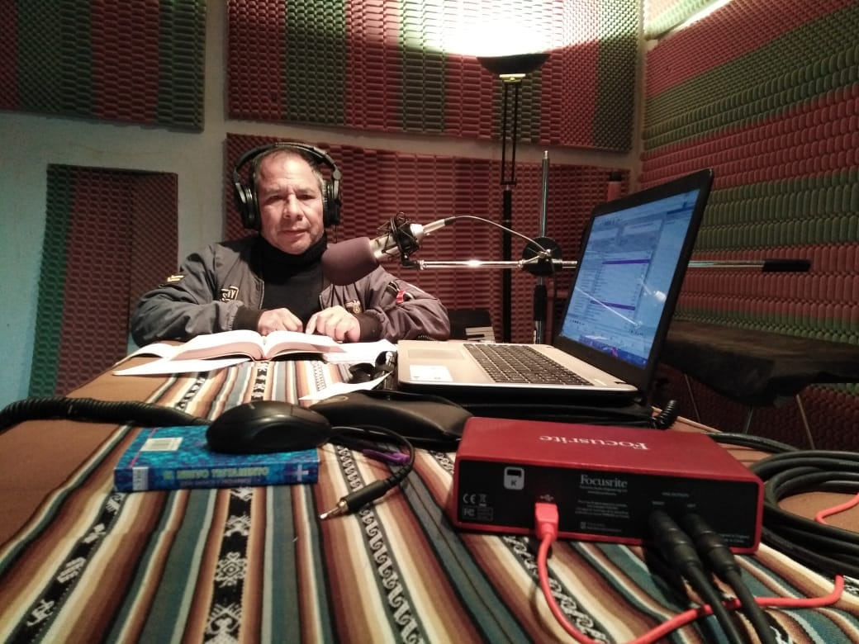
Pastor Santiago ministers a live program with the Quechua scriptures as he comforts anxious listeners.

Seminary courses begin this week by way of internet! This is going to better prepare the church planters and pastors for obedient and effective ministries as they work to clarify their teaching among so many with spiritually confused and dark practices of witchcraft and idolatry.

We’re thankful for the lives and ministries of those in Cotahuasi: Fredy, Santiago, Jeremias, Aldo, Camilo, and their families. They daily comment about how much more spiritually open and serious the people have been over the last couple of months. They note that the gospel is more openly received now, and born-again believers are listening more frequently to the radio bible teaching programs and finding peace and encouragement in the truth of God’s precious word.
Our focus has changed from an emphasis of church planting and frequent church meetings in the various villages, to more careful preparation of radio teaching and mercy ministry outreach to the many suffering families who do not have any income opportunities now. Many in our community augment their income with farming, and those who are the poorest subsistence farmers have at least some food for their families.
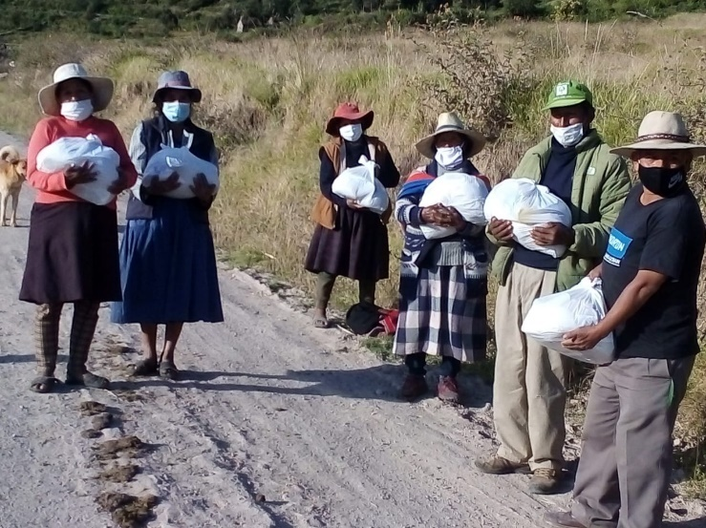

Believers from the village church of Locrahuanca
(low-craw-wong-ka) are thankful and encouraged.

Prayer and Praise:
Give Thanks:
-That the Lord is blessing through the current suffering and tremendous openness and spiritual hunger.
-Please pray for the team of Quechua church planters, their spiritual growth, and their studies in theological education.

-Pray for the slowing of the progress of the short-wave radio station project and the difficulties for all involved in licensing and installation. This is important to progress in this because the broadcast of faithful bible teaching could reach millions of Quechua speakers.

-Pray for God to be glorified through radio, theological training, discipleship and biblical counseling.

-Pray for continued financial provision for the Quechua church planters, theological education, and the radio antenna and transmitter projects.

-Pray for safety on dangerous mountain roads and the personal discipline of each, as they visit villages, and when they run daily errands.

Thank you!

Your faith and love for Him, your prayers and support, are a huge blessing & encouragement to us and the Quechua team in the Cotahuasi Canyon.

Please write us at:

bradley.shaw@sim.org gina.shaw@sim.org

Face book page: Quechua Missions – Cotahuasi

How to support the ministry and project

Donations are made to SIM by sending a check to:
SIM Donor Care, 14830 Choate Circle
Charlotte, NC 28273

The Shaw’s SIM support/ministry account is # 52192

To give electronically please visit
www.quechuamissions.com

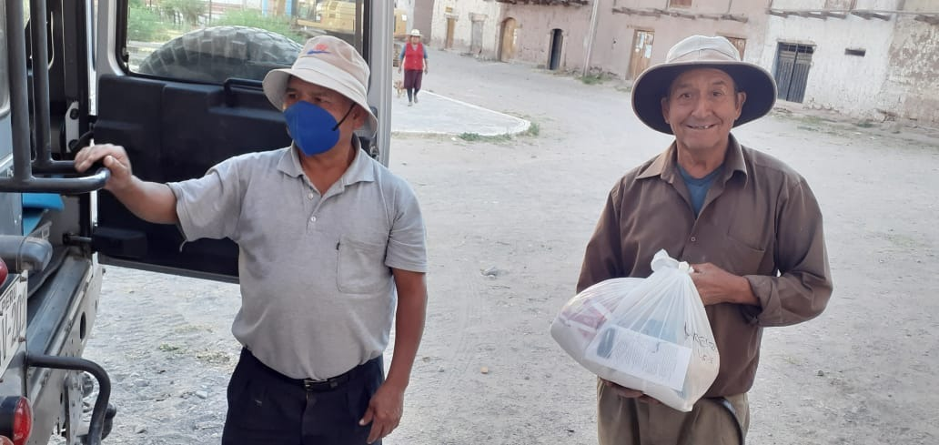

Right: Pastor Lorenzo said thank you!
He lost both of his brothers because of the very poor health care system in our area of Peru.

Pray for his strength and health please.

