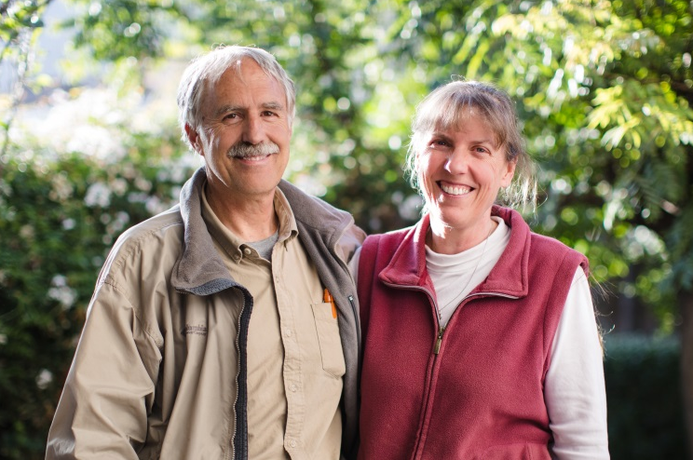

Dear precious friends in Christ,

We have just arrived back to Peru and as we settle back into our routine and various ministry responsibilities, we are thankful for the grace and power of God sanctifying His church and growing it for His glory. He is working all over the world, and this summer we saw it as we visited friends and churches in America. And it is a blessing to see it here in Peru also, in the little village churches and isolated families who live in the Cotahuasi Canyon.

Our short 2017 home assignment was quite different this time, with a focus on our own families who needed time for healing, physically and emotionally. Brad’s mother passed away and Gina’s father had cancer and surgery treatment.

In our absence, the church planting and radio ministries have continued. Fredy faithfully led while we were away, serving along with Santiago, Camilo, Faustino, Patty, Lorenzo and Deysi.

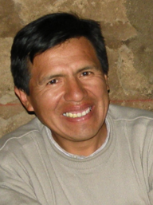
Fredy Lorenzo Patty

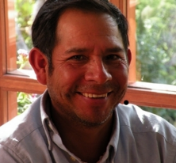
Faustino Deysi Santiago

Radio outreach
Over the last few years we have been praying and asking the Lord to use us to reach out even further into remote areas and cities of Southern Peru using Christian radio. Hardly anyone here has a way to hear the true gospel and get biblical teaching. There is so much religion, but little is grounded in the truth of scripture. Some new opportunities are being presented to us, including two openings for licenses that could allow us to reach many more. As we look forward and we work to meet the government requirements, please pray with us for honest and competent companies to assist us in the necessary steps, and the financial provision to install and maintain the new stations.

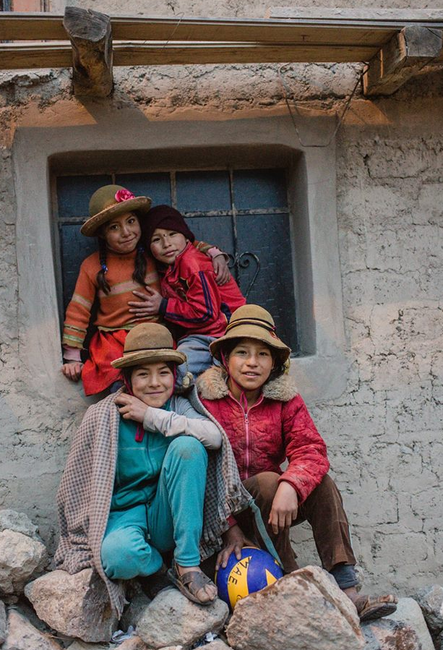
These children attend a public school where we visit monthly to share the gospel and teach Bible. Pray that these kinds of freedoms and opportunities will continue. They have not always been this way.

Youth and Children
We find ourselves in an interesting situation with public schools teaching religion as if it matters. Currently, in most of the rural schools in our region, we are welcomed to come and teach the Bible and freely share the gospel. We could really do more if we had more workers to serve here with us. Each month when we head up into the upper canyon, we stop and visit the village schools.

Women’s Bible study
Gina enjoys teaching a group of friends each Thursday afternoon. With a goal of going slow, some are getting fresh insight and real understanding of basic Bible doctrines of the faith.

Church planting in the highlands
Quechua shepherds isolated in remote areas of the Andes Mountains have little opportunity to learn about the one true God, His love, and His truth. Each month our church planting team goes up into the high-altitude area where we would like to see new believers established into local churches. Our efforts include meeting with families, teaching in small groups, and praying for how to help build meeting places where they can fellowship. Their houses are too small for groups to meet in them.
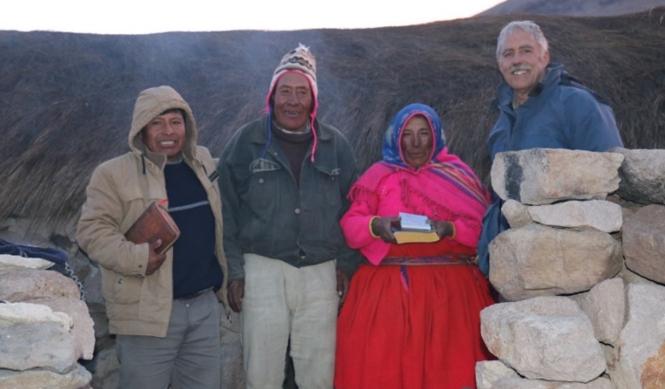

The only Christians in their area. Neither of them can read but they cherish their Bible and Quechua hymnal. Living in a 6 x15 foot hut behind them at 16,200 feet above sea level.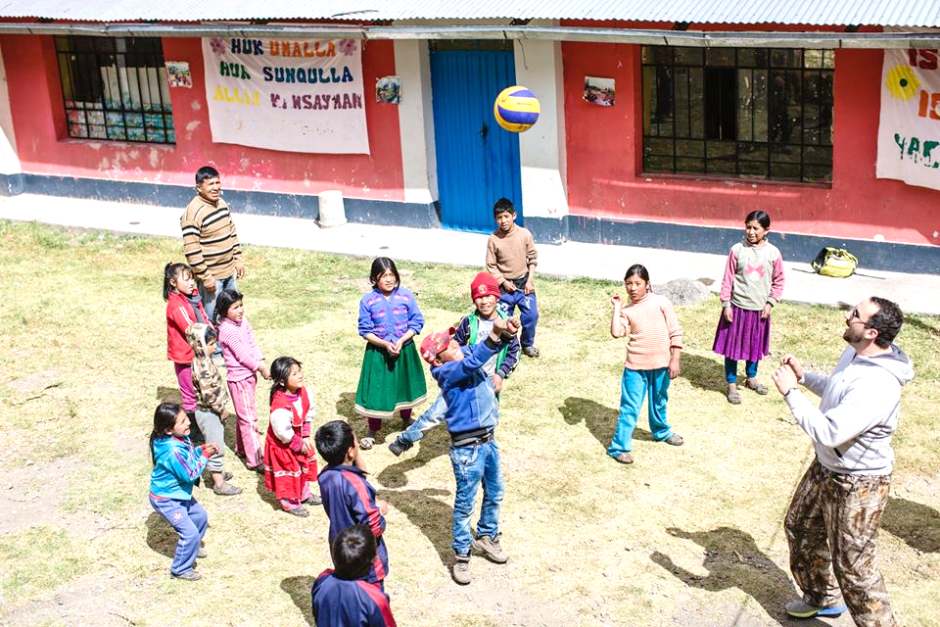
Groups who come for short visits always bring enthusiasm and encouragement as we all grow in our faith together.

Prayer and Thanksgiving
1. Give thanks for the successful importation and installation of the new FM transmitter, which is functioning well.
2. Give thanks for the provision and smooth process in the completion of our mile long power line to the transmitter site !
3. Give thanks for the completion of the Foundations of the Faith Quechua Bible study radio program.
4. Give thanks for the opportunity to compete in acquiring licenses for new radio frequencies that could allow us to reach many more people with the gospel and daily Bible teaching.
5. Give thanks for new and improved internet access.

1. Please pray for the process of meeting requirements and the successful bidding necessary to compete for two frequencies made available by the government to the public.
2. Please continue to pray for more workers to serve with us in church planting, discipleship, radio program broadcasting and preparation of Quechua teaching materials. This year, two missionary families have needed to move, and Patty and Deysi will be moving away next month.
3. Please pray for the Lord to send more help with our Bible teaching outreach to children. Now there are many opportunities to minister to children. Ask the Lord of the harvest to send long term workers to help.
4. Please pray for the vision and work teams now preparing to briefly visit in the Spring and Summer of next year.
5. Please pray for the health, strength and also safety of our team as we travel on dangerous narrow mountain roads.

How to support the work and workers:
The Cotahuasi Ministry Project is SIM project #91252 and donations are made to SIM by sending a check to: SIM Donor Care, P.O. Box 7900, Charlotte, NC 28241.

To give electronically please visit
http://quechuamissions.com/give

Or call SIM USA at 1800-521-6449 ext. 1467

How to contact Brad and Gina:
bradley.shaw@sim.org gina.shaw.peru@gmail.com

Our Cotahuasi ministry web site that shows and tells all about the work: www.quechuamissions.com

Face book page: Quechua Missions – Cotahuasi

Thank you again for participating with us in reaching the La Union Quechua people through prayer, financial gifts, and all of your encouragement.

Now may the God of peace himself sanctify you completely, and may your whole spirit and soul and body be kept blameless at the coming of our Lord Jesus Christ. 1 Thessalonians 5:23

Love, Brad and Gina

